***Work Experience Report – Mihaela Bet***

[](https://www.google.ie/url?sa=i&rct=j&q=&esrc=s&source=images&cd=&cad=rja&uact=8&ved=0ahUKEwiFgtWOh7rSAhVlKcAKHeb8DjYQjRwIBw&url=https://digitalmarketingjobs.ie/eirgen-pharma-create-40-jobs-south-east-ireland/&psig=AFQjCNGoOF4p7DINJHR0qqNikKOT3O_aKw&ust=1488620870173686)My work placement for the 9th – 20th January 2017 was at EirGen Pharma in Co. Waterford. They are a company that works in the development, registration, manufacture and supply of high-potency pharmaceutical products to global markets. They work with companies worldwide and alongside agencies such as FDA and the EMA.

*Description of work*

[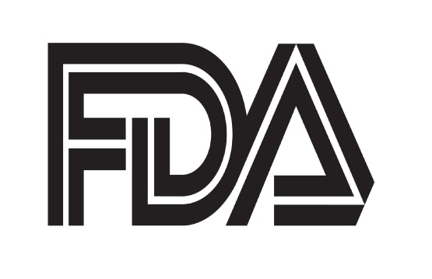](http://www.google.ie/url?sa=i&rct=j&q=&esrc=s&source=images&cd=&cad=rja&uact=8&ved=0ahUKEwjKnJ7Hh7rSAhUpKMAKHaGRDb0QjRwIBw&url=http://www.eirgen.com/eirgen-pharma-successfully-completes-gmp-facility/&psig=AFQjCNGoOF4p7DINJHR0qqNikKOT3O_aKw&ust=1488620870173686)My working hours during my work experience were from 9:00 – 3:00. I was mostly in the pre-formulation department. This is a stage of development during which the physiochemical properties of drug substances are analysed. The work I carried out at EirGen Pharma was mostly computer based in the pre-formulation area. In the pre-formulation department I researched MSDS (Material Safety Data Sheets) for substances used in the laboratory. I also worked in Excel logging in deliveries to and from the company on a spread sheet document. I also spent some of the days in Regulatory Affairs and in Quality Control. I verified documents, logged in batch no’s and printed a dossier on a product for the FDA inspection. In Quality Control I organised training files/packs in the documentation vault into each employee’s folder.

*People I met*

I met many people in different areas of the company, such as pre-formulation, formulation, quality control and regulatory affairs. I was with Rachel who works in pre-formulation for the majority of my time in EirGen, as she was in charge of me during the duration of my work experience at EirGen. I noticed that the atmosphere in the company was very positive and friendly, especially towards newcomers.

*Skills used*

The skills I used include:

* Communication skills
* Computer skills
* Organisational skills

Computer skills were extremely important as I spent most of my time working on a computer. I used programmes such as Word and Excel. I found this to be quite easy and it was not problematic at all.

Communication skills were also important as I worked with the pre-formulation team on various tasks I had to complete such as the research of MSDS.

Organisational skills proved to be very convenient during my time with Quality Control, as there were 100’s of files to be organised in a short period of time.

*Aspects liked*

I really enjoyed the overall experience of working at EirGen. I liked the research involved in the creation of new products.

*Aspects not liked*

I would have liked to also be in the formulation labs. I did not enjoy being based at a computer all day and I would have preferred to be working in the labs. I would have found this more interesting and intellectually stimulating.

*Challenges*

The one challenge I remember quite well was the organisation of many documents into piles in a short period of time in Quality Control. I found this to be challenging even when I was very organised, especially as there was a large influx of documents for the FDA inspection.

*Possible future careers/courses*

|  |  |  |  |  |
| --- | --- | --- | --- | --- |
| CAO | COURSE | PLACE | POINTS | YEARS |
| DC162 | Chemical & Pharmaceutical Science | DCU | 490 | 4 |
| RC005 | Pharmacy | RCSI | 545 | 5 |
| GY318 | Biopharmaceutical Chemistry | NUIG | 500 | 4 |