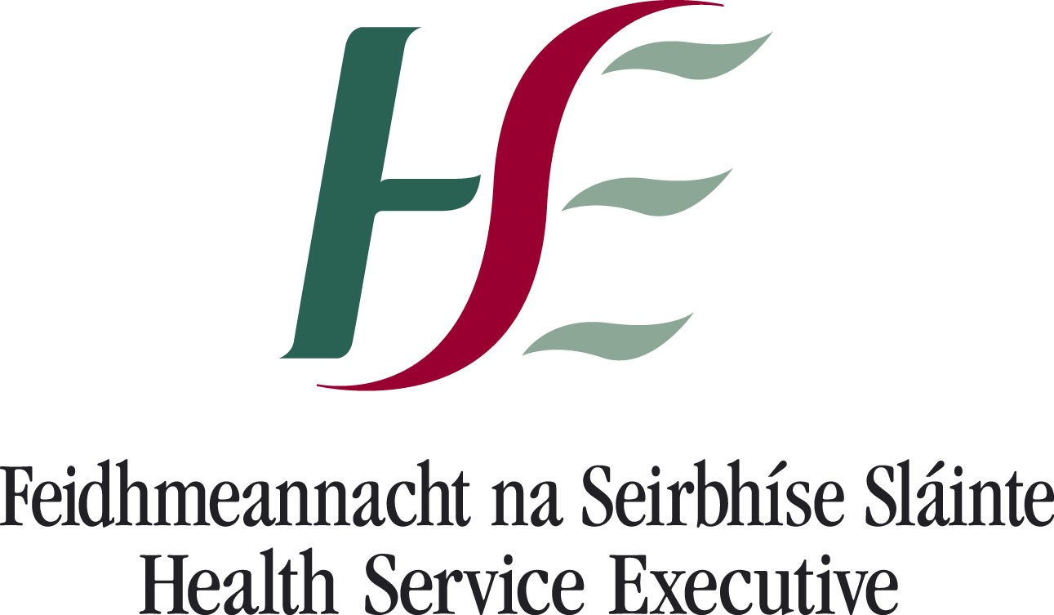

# 14/09/2020

**Re: Confirmed case of COVID-19 at your child’s school.**

A confirmed case of COVID-19 in your child’s school, has been notified to the Department of Public Health HSE SE**.**

A public health risk assessment has been undertaken and the parents of any children deemed to be close contacts of the confirmed case have been contacted and advised accordingly. If your child has not been identified as a close contact at this time, your child does not need a test for Covid-19, they can continue to attend school, and no further actions are required at this time.

If your child develops any symptoms suggestive of Covid-19 infection (such as a cough, a fever, loss or change in sense of taste or smell), please do not send your child to school, contact your GP and begin restricting your child’s movements, as per public health advice.

**Restricted movement** means avoiding contact with other people and social situations as much as possible. It is also sometimes called ‘self-quarantine’.

Restricted movement means that your child stays home and:

* Does not go to school.
* Does not use public transport.
* Does not have visitors in your home.
* Does not go to the shops or pharmacy, unless absolutely necessary.
* Keeps away from older people, anyone with an underlying medical condition and pregnant women.

Further information on COVID-19 is available at: [www.hpsc.ie](http://www.hpsc.ie/) and [www.gov.ie](http://www.gov.ie/) Or phone Public Health South East at 056 7784142 or HSE Live at 1850 24 1850

Yours sincerely,

Dr Elaine Neville MCRN 19171 SMO Public Health