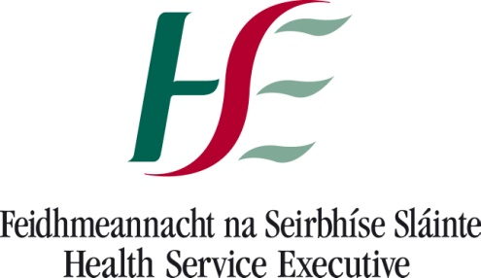 23/10/2020

Re: Confirmed case of COVID-19 at your school-no close contacts.

A confirmed case of COVID-19 in your school has been notified to the Department of Public Health HSE SE.

A public health risk assessment has been undertaken and nobody was deemed to be a close contact of the confirmed case. As you/ your child have not been identified as a close contact at this time, you/your child do not need a test for COVID-19, can continue to attend school, and no further actions are required at this time.

If you/your child develop any symptoms suggestive of COVID-19 infection (such as a cough, a fever, loss or change in sense of taste or smell), please do not go to school or send your child to school, contact your GP and begin restricting your/your child’s movements, as per public health advice. Your household members also need to restrict their movements if there is someone symptomatic in the house.

Restricted movement means avoiding contact with other people and social situations as much as possible. It is also sometimes called ‘self-quarantine’.

Restricted movement means that you/your child stay home and:
- Do not go to school.
- Do not use public transport.
- Do not have visitors in your home.
- Do not go to the shops or pharmacy, unless absolutely necessary.
- Keep away from older people, anyone with an underlying medical condition and pregnant women.

Further information on COVID-19 is available at: www.hpsc.ie and www.gov.ie
Or phone HSE Live at 1850 24 1850

Yours sincerely,

Dr Elaine Neville MCRN 19171
SMO Public Health

