**OUR LADY OF MERCY SECONDARY SCHOOL**



**OZANAM STREET**

**WATERFORD**

Telephone 051 373476

School Roll No: 64971W

RCN Number: 20148133

E-mail office@mercywaterford.com

**Meánscoil Mhuire na Trócaire**

**Portláirge**

9th January 2024

Dear Parent’s / Guardians of 2nd Year students,

Your daughters parent teacher meeting is online on Wednesday 17th January, 2024 at 16.15pm – 18.45pm Please follow these steps in order to gain access to your child’s Parent Teacher Meeting via the following link; <https://ptmorg.com/parentlogin.php?School=64971W>. **You must pre- register by Friday12th .**

Your daughters Student ID

will b

e

sent via text.

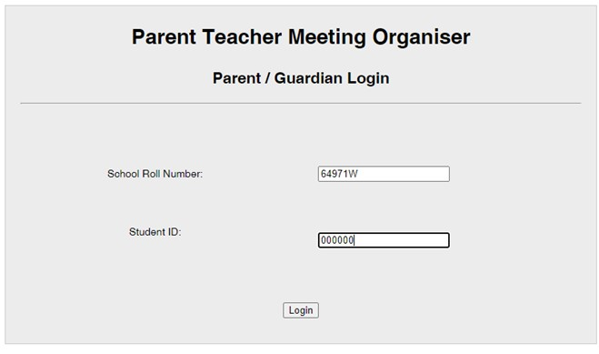

Once logged in you will be directed to the below page where you will see a list of your daughter’s subjects and on this page, you will put your preference in order and please click if you can or cannot attend the meeting.

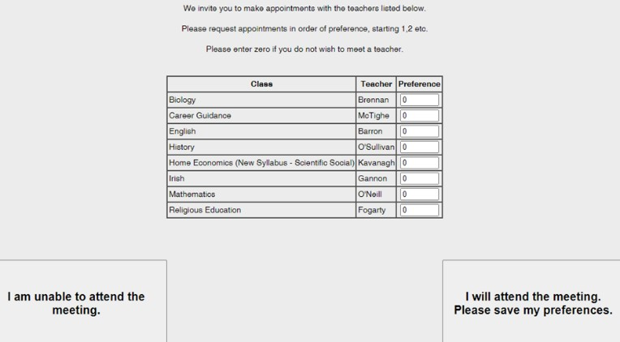

Kind Regards,

Mary Meade

**PRINICPAL**